Chapter 4, Problem 61.

Obtain the Thevenin and Norton equivalent circuits at terminals a-b of the circuit in Fig. 4.127.

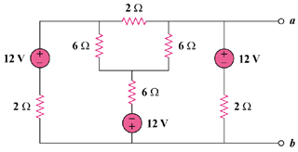

Figure 4.127
For Prob. 4.61.

